**Day 10**

**Process mangement**

**Definition:**

An instance of a program is called a process.In simple terms any command that you give to the linux machine starts a new machine.

**Types of Process:**

**1.Foreground:**

They run on the screen and need input from the user.(**office program**)

**2.background:**

They run in the background and usally do not need user input.(**antivirus**)

**Top:**

To check what the process is running.

**Command (ps -efa)**

**PS -** Current process status.

**E -** list very process on the system

**F -** This Display full format listing shows a total information about each process.

**A -** Include all processes associated with the terminals including both of the other uses.

**Command** (**ps -auxe**)

**PS -** Current process running status.

**A -** Shows information about all users.  
**U -** Shows additional information.

**X -** Shows information about the process without terminals.

**E -** Display Extended information.

**USER PID %CPU %MEM VSZ RSS TTY STAT START TIME COMMAND**

**User -** user id or name

**PID -** Process id

**CPU -** The percentage % of cpu the process currently consuming

**MEM -** The percentage % of memory the process currently consuming

**VSZ -** The size of processing kilo byte

**RSS -** Residual set size the non swapped physical memory the process is used

**TTY -** Terminal associated process

**STAT -** The process to running or sleep or zombing

**START -** The start time date when process started

**TIME -** Total time cpu used by the process

**Command -** The command that is start the process

**1.usd to seconds also adding this command using to sleep**

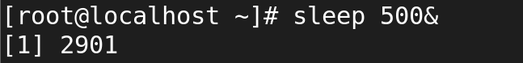

**2.process view to the command is jobs**



**3.over all process running to view the command is ps - aux**





**4.Foreground process will be view the command is fg 1 and not contain will typing to fg**

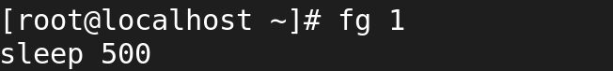

**5.again you will next to back command is ctrl z**

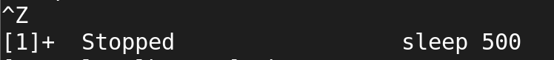

**6.Back ground process will be view the command is bg 1**

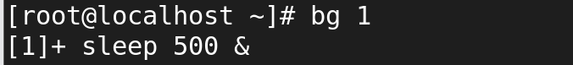

**7.over all process running to view the command is ps - aux**





**8.next removing the process command is kill -15 pid no to add to remove**



**9.next again to removing the status to command ps -aux**





**10.And ps -auxe command to be used in display extended information**





**11.process to create the priority and command is renice - -priority 10 - - pid 3272**



